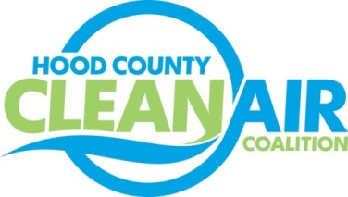
Meeting: Wednesday, November 7, 2018
Neely House
304 East Rucker Street, Granbury, Texas 76048
8:30-10:00 a.m.

Agenda

- Call Meeting to Order
- EPA Updates – Randy Pitre, EPA
- Local Updates – Michelle McKenzie
  - Review of October Meeting Summary
  - Review of Projects
    - Monthly Budget Review for September
    - Status of Projects
  - Reports
    - October Ozone Update
    - Intergovernmental Coalition Meeting
    - Weatherford College STEMania
    - Propane Autogas Lunch and Learn
- Regional Updates – Michelle McKenzie
Funding Opportunities: www.nctcog.org/aqfunding
- Other Discussion
- Adjourn

